**Performance Testing**

**SIGNS WITH SMART CONNECTIVITY FOR BETTER ROAD SAFETY**

**Team Id: PNT2022TMID27042**

**Testing 1**

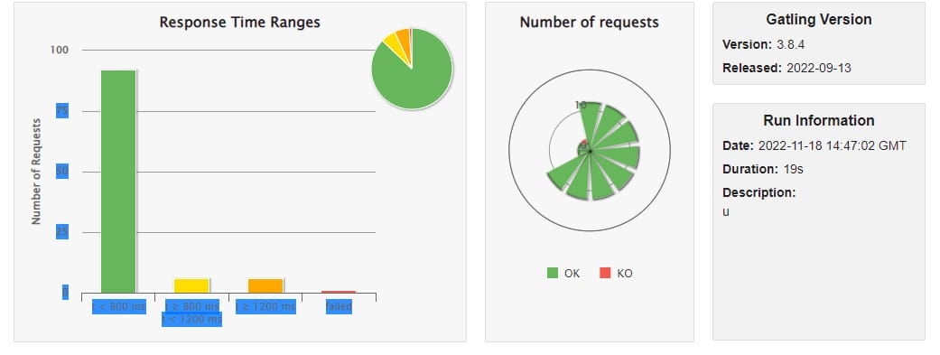

**Testing 2**

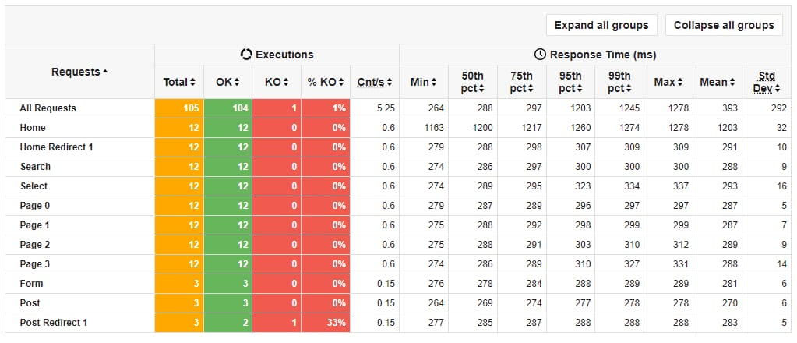

**Testing 3**

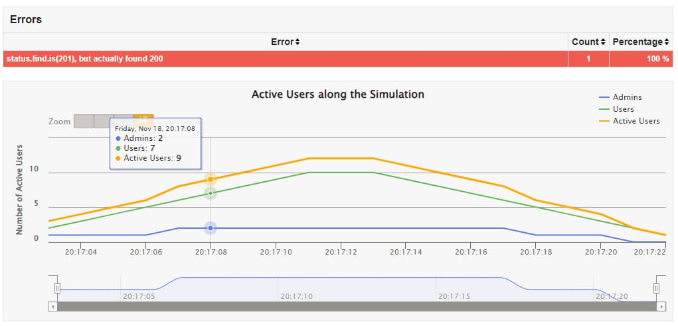

**Testing 4**

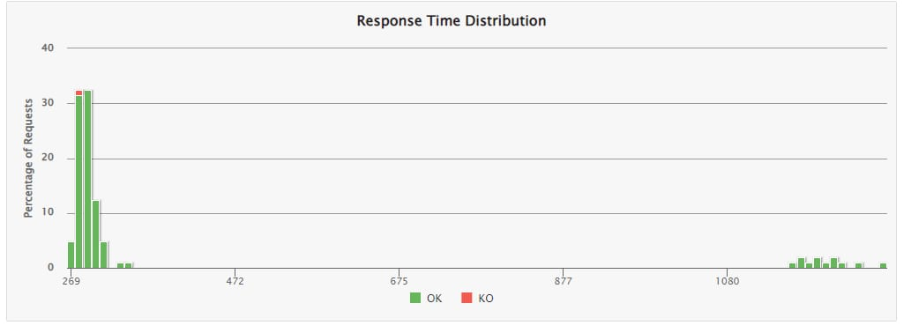

**Testing 5**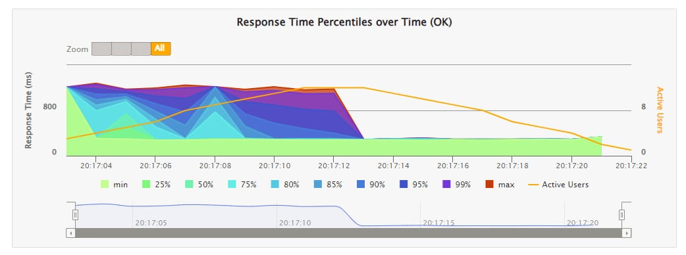

**Testing 6**

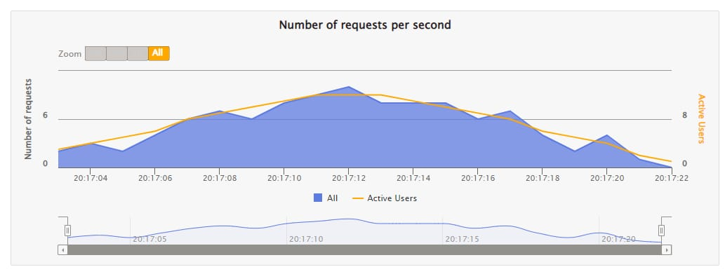

**Testing 7**

